- Demonstration of preprocessing on dataset student.arff

Weka - Preprocessing the Data. The data that is collected from the field contains many unwanted things that leads to wrong analysis. For example, the data may contain null fields, it may contain columns that are irrelevant to the current analysis, and so on.

Step1: Loading the data. We can load the dataset into weka by clicking on open button in preprocessing interface and selecting the appropriate file.
Step2: Once the data is loaded, weka will recognize the attributes and during the scan of the data weka will compute some basic strategies on each attribute. The left panel in the above figure shows the list of recognized attributes while the top panel indicates the names of the base relation or table and the current working relation (which are same initially).
Step3: Clicking on an attribute in the left panel will show the basic statistics on the attributes for the categorical attributes the frequency of each attribute value is shown, while for continuous attributes we can obtain min, max, mean, standard deviation and deviation etc.,
Step4: The visualization in the right button panel in the form of cross-tabulation across two attributes.
Note:we can select another attribute using the dropdown list.
Step5:Selecting or filtering attributes Removing an attribute-When we need to remove an attribute,we can do this by using the attribute filters in weka.In the filter model panel,click on choose button,This will show a popup window with a list of available filters. Scroll down the list and select the “weka.filters.unsupervised.attribute.remove” filters.
Step 6:a)Next click the textbox immediately to the right of the choose button.In the resulting dialog box enter the index of the attribute to be filtered out.
b)Make sure that invert selection option is set to false.The click OK now in the filter box.you will see “Remove-R-7”.
c)Click the apply button to apply filter to this data.This will remove the attribute and create new working relation.
d)Save the new working relation as an arff file by clicking save button on the top(button)panel.(student.arff)
Procedure:
Choose TabWekafiltersSupervisedattributeDiscretize

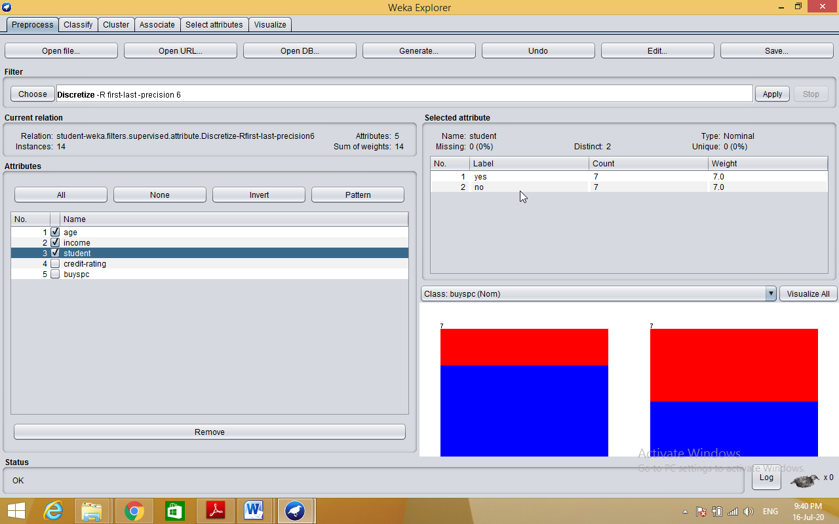

Dataset student .arff
@relation student
@attribute age {<30,30-40,>40}
@attribute income {low, medium, high}
@attribute student {yes, no}
@attribute credit-rating {fair, excellent}
@attribute buyspc {yes, no}
@data
%
<30, high, no, fair, no
<30, high, no, excellent, no
30-40, high, no, fair, yes
>40, medium, no, fair, yes
>40, low, yes, fair, yes
>40, low, yes, excellent, no
30-40, low, yes, excellent, yes
<30, medium, no, fair, no
<30, low, yes, fair, no
>40, medium, yes, fair, yes
<30, medium, yes, excellent, yes
30-40, medium, no, excellent, yes
30-40, high, yes, fair, yes
>40, medium, no, excellent, no
%

Program 2: Demonstration of Association rule process on data set contactlenses.arff using apriori is an algorithm

Description: finding frequent itemsets using candidate generation
Apriori algorithm is a seminal algorithm proposed by R.agrawal and R.srikant in 1994 for mining frequent itemsets for boolean association rules.the name of the algorithm is based on the fact that the algorithm uses prior knowledge of frequent itemset properties .apriori employs an iterative approach known as a level-wise search ,where k-itemsets are used to explore (k+1) itemsets.

Apriori property: all nonempty subsets of a frequent itemset must also be frequent it has two steps
- join step
- Prune step

Procedure :

Step 1: load appropriate data set into weka

Step 2: select associate tab and select apriori algorithm

Apriori algorithm with 0.25 support and 0.9 confidence values .

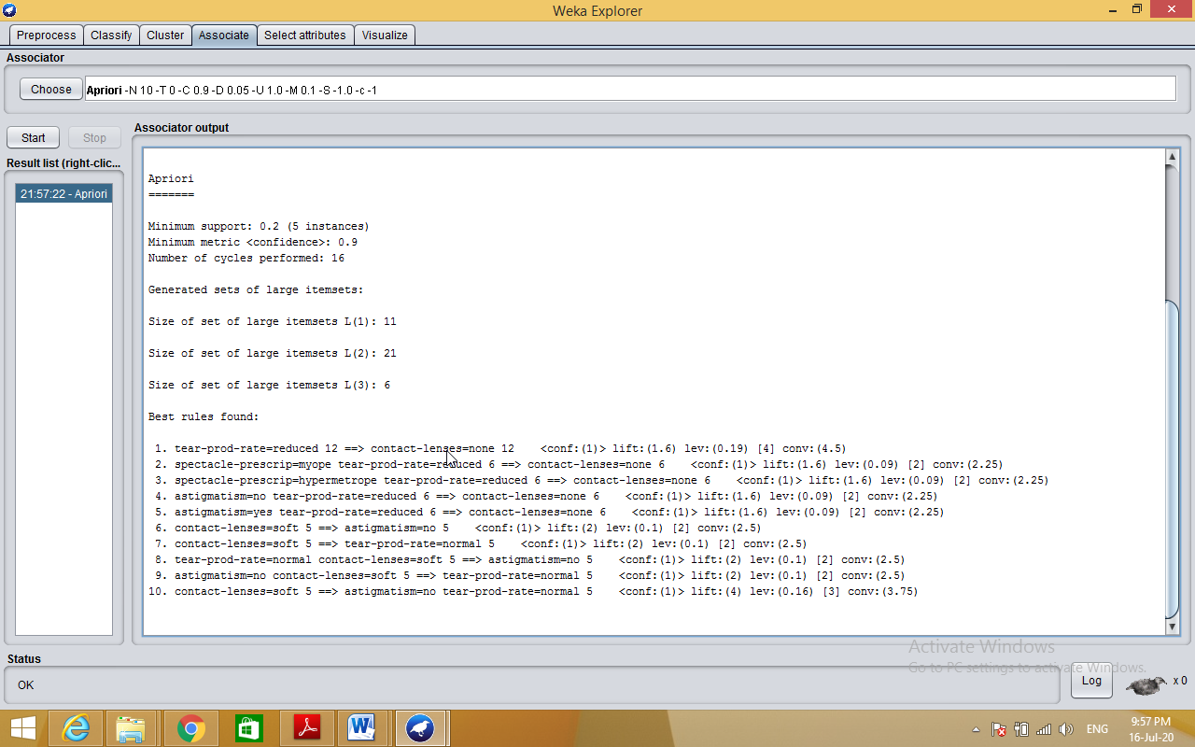

Dataset contactlenses.arff
@relation contact-lenses
@attribute age {young,pre-presbyopic,presbyopic}
@attribute spectacle-prescrip {myope,hypermetrope}
@attribute astigmatism {no,yes}
@attribute tear-prod-rate {reduced,normal}
@attribute contact-lenses {soft,hard,none}
@data
%
% 24 instances
%
young,myope,no,reduced,none
young,myope,no,normal,soft
young,myope,yes,reduced,none
young,myope,yes,normal,hard
young,hypermetrope,no,reduced,none
young,hypermetrope,no,normal,soft
young,hypermetrope,yes,reduced,none
young,hypermetrope,yes,normal,hard
pre-presbyopic,myope,no,reduced,none
pre-presbyopic,myope,no,normal,soft
pre-presbyopic,myope,yes,reduced,none
pre-presbyopic,myope,yes,normal,hard
pre-presbyopic,hypermetrope,no,reduced,none
pre-presbyopic,hypermetrope,no,normal,soft
pre-presbyopic,hypermetrope,yes,reduced,none
pre-presbyopic,hypermetrope,yes,normal,none
presbyopic,myope,no,reduced,none
presbyopic,myope,no,normal,none
presbyopic,myope,yes,reduced,none
presbyopic,myope,yes,normal,hard
presbyopic,hypermetrope,no,reduced,none
presbyopic,hypermetrope,no,normal,soft
presbyopic,hypermetrope,yes,reduced,none
presbyopic,hypermetrope,yes,normal,none

%
%

3. Demonstration of classification rule process on dataset employee.arff using j48 algorithm.

Aim: This experiment illustrates the use of j-48 classifier in weka. The sample data set used in this experiment is “student” data available at arff format. This document assumes that appropriate data pre processing has been performed.
Steps involved in this experiment:
Step-1: We begin the experiment by loading the data (student.arff)into weka.
Step2: Next we select the “classify” tab and click “choose” button t o select the “j48”classifier.
Step3: Now we specify the various parameters. These can be specified by clicking in the text box to the right of the chose button. In this example, we accept the default values. The default version does perform some pruning but does not perform error pruning.
Step4: Under the “text” options in the main panel. We select the 10-fold cross validation as our evaluation approach. Since we don’t have separate evaluation data set, this is necessary to get a reasonable idea of accuracy of generated model.
Step-5: We now click ”start” to generate the model .the Ascii version of the tree as well as evaluation statistic will appear in the right panel when the model construction is complete.
Step-6: Note that the classification accuracy of model is about 69%.this indicates that we may find more work. (Either in preprocessing or in selecting current parameters for the classification)
Step-7: Now weka also lets us a view a graphical version of the classification tree. This can be done by right clicking the last result set and selecting “visualize tree” from the pop-up menu.
Step-8: We will use our model to classify the new instances.
Step-9: In the main panel under “text” options click the “supplied test set” radio button and then click the “set” button. This wills pop-up a window which will allow you to open the file containing test instances.
Description:
Classification is a data mining function that assigns items in a collection to target categories or classes. The goal of classification is to accurately predict the target class for each case in the data. For example, a classification model could be used to identify loan applicants as low, medium, or high credit risks.
Entropy characterizes the (im) purity of an arbitrary collection of examples
Information Gain is the expected reduction in entropy caused by partitioning the examples according to a given attribute
If we have a set with k different values in it, we can calculate the entropy as follows:

Where P(valuei) is the probability of getting the ith value when randomly selecting one from the set. So, for the set R = {a,a,a,b,b,b,b,b}

Kappa statistic is a measure of how closely the instances classified by the machine learning classifier matched the data labeled as ground truth, controlling for the accuracy of a random classifier as measured by the expected accuracy.
Decision tree builds classification or regression models in the form of a tree structure. It breaks down a dataset into smaller and smaller subsets while at the same time an associated decision tree is incrementally developed. The final result is a tree with decision nodes and leaf nodes.
Classifier Accuracy Measures
The confusion matrix is a useful tool for analyzing how well your classifier can recognize tuples of different classes.

F measure (F1 score or F score) is a measure of a test's accuracy and is defined as the weighted harmonic mean of the precision and recall of the test.
TP Rate: rate of true positives (instances correctly classified as a given class)
FPRate: rate of false positives (instances falsely classified as a given class)

Precision is the fraction of retrieved data that are relevant to the query:
Recall is the fraction of the relevant data that are successfully retrieved.
Cross-validation: In k-fold cross-validation, the initial data are randomly partitioned into k mutually exclusive subsets or “folds,” D1, D2: Dk, each of approximately equal size.
Predictor Error Measures

Procedure:
Step 1: Load appropriate dataset into WEKA.
Step 2: Select classify TAB and select J48 algorithm.

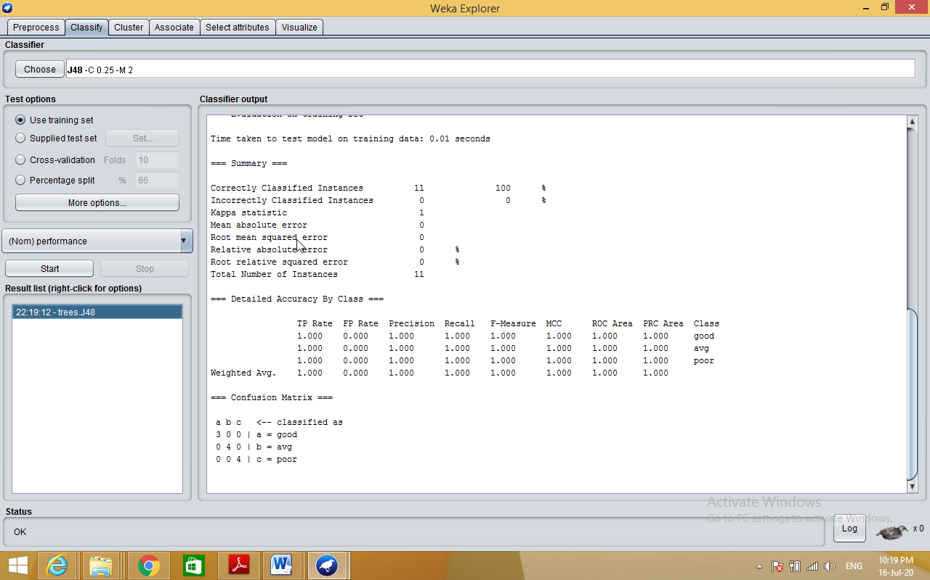

Generating Decision Tree:-
Right click on result listselect visualize tree option

